SELECTED WORK | 2025/2026
ACADEMIC &
TECHNICAL PORTFOLIO
ABDULRAHMAN ALGAILANI
Computer Science Student | C++ Programming | Artificial Intelligence | Systems Analysis & Design
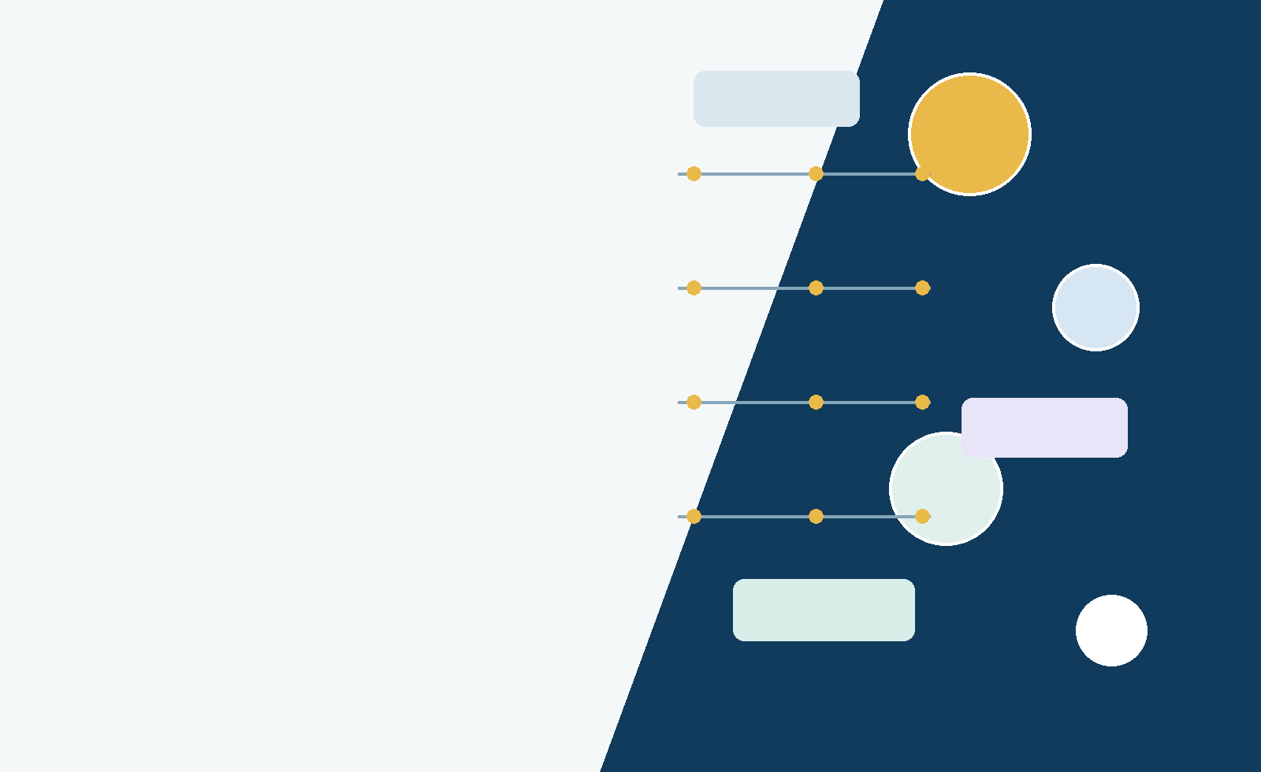
Universiti Sains Malaysia
School of Computer Sciences

01 | Profile  A concise overview of academic focus, strengths, and portfolio contents

Professional Summary
Computer Science student at Universiti Sains Malaysia with practical coursework in object-oriented C++ programming, artificial-intelligence search strategies, and systems analysis and design. The academic profile also includes LSP201 English and AKW103 Management, providing supporting exposure to communication and management fundamentals. The work in this portfolio demonstrates an ability to translate real-world problems into structured requirements, class models, algorithms, user workflows, and testable technical solutions.
TECHNICAL STRENGTHS  • C++11/C++17 and g++ compilation  • Object-oriented design and multi-file programs  • Recursion, pointers, vectors, dynamic memory  • File input/output and exception handling  • A* Search, CSP, and Backtracking Search | ANALYSIS & COMMUNICATION  • Functional and non-functional requirements  • Use-case, class, activity, and sequence diagrams  • Architecture, security, and testing plans  • LSP201 English: academic communication  • AKW103 Management: management fundamentals

Portfolio Contents
04 | Hotel Review System | Object-oriented C++ application
07 | Mini File System Explorer | Recursive hierarchical file management
08 | GreenPlate | Campus food-waste reduction platform
11 | Smart Shuttle & Eco Room | Intelligent-agent design for USM
13 | Competency Evidence | Skills matrix, reflection, supporting coursework, and project archive
Contact
UNIVERSITY  Universiti Sains Malaysia | EMAIL  abdulrahmanalgailani@student.usm.my | DISCIPLINE  Computer Science

02 | Project Map  Four projects showing progression from programming fundamentals to system and AI design

4  SELECTED PROJECTS | 2  WORKING C++ APPLICATIONS | 2  TEAM DESIGN PROJECTS | 5  ACADEMIC MODULES

Selected Project Overview
PROJECT | COURSE | FOCUS | ROLE / OWNERSHIP
Hotel Review System | CKC112 | C++ OOP, ranking, one-time file I/O | Primary author listed in notebook
Mini File System Explorer | CKC112 | Recursion, pointers, vectors, multi-file C++17 | Primary author listed in notebook
GreenPlate | CCA103 | Requirements, UML, architecture, controls, testing | Module 3: Logistics and Pickup
Smart Shuttle & Eco Room | CKC113 | PEAS, A*, CSP/backtracking, responsible AI | Group member and co-author
Progression Across the Portfolio
01  Model the domain  Identify classes, users, goals, and constraints. | 02  Choose the mechanism  Use OOP, recursion, graph search, or constraint solving. | 03  Document the design  Create UML, requirements, interfaces, and algorithm traces. | 04  Verify the result  Compile, run demonstrations, plan tests, and evaluate limitations.
PORTFOLIO POSITIONING
The selected work combines executable programming assignments with broader system-design and AI projects. Together, the projects show both implementation ability and structured technical reasoning.

01 | Hotel Review System  CKC112 Programming Assignment 1 | Object-oriented C++ console application

Project Overview
A menu-driven hotel review application that loads traveler and review records, stores reviews inside registered-traveler objects, supports search and ranking operations, accepts new reviews during runtime, and writes updated files once before termination.
10  TRAVELER RECORDS | 7  CORE MENU FUNCTIONS | 4  REQUIRED OOP CONCEPTS | 2  UPDATED OUTPUT FILES

Core User Functions
DISCOVERY & ANALYTICS  • Property Deep-Dive with review count, average rating, and best review  • Traveler Profile with identity, membership, loyalty points, and authored reviews  • Top-Pick Matcher ranking hotels by average rating  • Top Reviewers ranking activity with loyalty-point tie-breaking | DATA & RUNTIME OPERATIONS  • Load Users.txt and Reviews.txt once at startup  • Attach reviews to travelers by user ID  • Add new reviews and award loyalty points  • Generate analytics through a friend function  • Write UpdatedUsers.txt and UpdatedReviews.txt once on exit

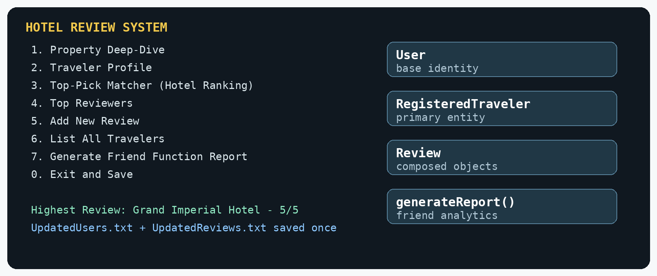
Console functions and the four-part object-oriented architecture.
DESIGN CONSTRAINT
The assignment intentionally avoided STL containers, virtual functions, abstraction layers, and placeholder Manager/System classes. The design therefore concentrates logic inside the primary RegisteredTraveler entity while using fixed-size arrays.

01 | Hotel Review System - Technical Evidence  CKC112 Programming Assignment 1 | Class design, relationships, and demonstrated outcomes

Object-Oriented Design
Inheritance | RegisteredTraveler is-a User and extends the shared identity fields.
Composition | Each RegisteredTraveler owns a fixed array of Review objects.
Operator overloading | Review::operator> ranks reviews by rating; RegisteredTraveler::operator> supports reviewer ranking.
Friend function | generateReport() accesses private traveler and review data to produce overall analytics.
Encapsulation | Search, ranking, matching, and aggregation logic remain in class member functions.

Design Rationale
OWNERSHIP MODEL  • main() works with one RegisteredTraveler array  • Traveler objects own their Review arrays  • A static attachment method matches review records to user IDs  • No Manager or System placeholder class is introduced | DATA LIFECYCLE  • Read Users.txt once at startup  • Read Reviews.txt once and attach records  • Perform all searches and rankings in memory  • Write both updated datasets once before termination

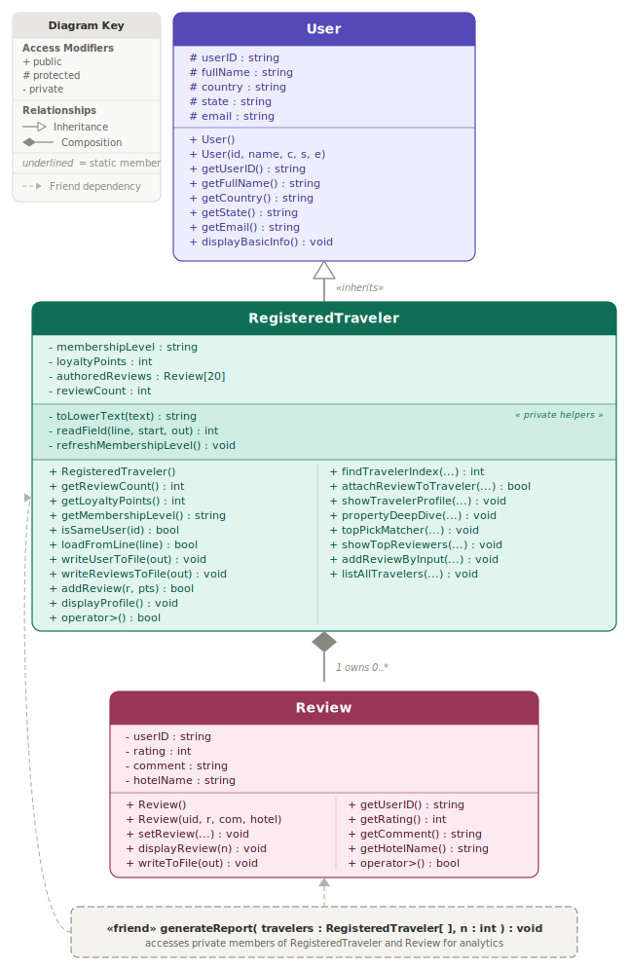
UML class diagram showing inheritance, composition, access modifiers, operators, and friend dependency.
Verification Evidence
BUILD & EXECUTION  • Compiled successfully with g++ using the C++11 standard  • Loaded the prepared traveler and review datasets  • Displayed ranking, profile, and property analysis outputs  • Saved updated user and review records before exit | WHAT THE PROJECT DEMONSTRATES  • Mapping assignment constraints to a valid class architecture  • Applying OOP concepts to real operations rather than isolated examples  • Combining file persistence with in-memory analytics  • Producing readable technical documentation and UML evidence

02 | Mini File System Explorer  CKC112 Programming Assignment 2 | Recursive, multi-file C++17 terminal application

Project Overview
A terminal-based explorer that models a hierarchical file system without using the C++ filesystem library. It loads an initial tree from a text file and lets the user create, browse, search, summarize, and delete folders and files.
CLASS STRUCTURE  • File stores a name and extension  • Folder stores files, parent pointer, and dynamically allocated subfolders  • FileSystem owns the root and current-folder pointers  • Separate .h and .cpp files support modular compilation | PROGRAMMING CONCEPTS  • Recursive full-tree display and file search  • Recursive memory cleanup through destructors  • Pointers and dynamic allocation with new/delete  • vector-based collections  • Exception handling for invalid and duplicate operations

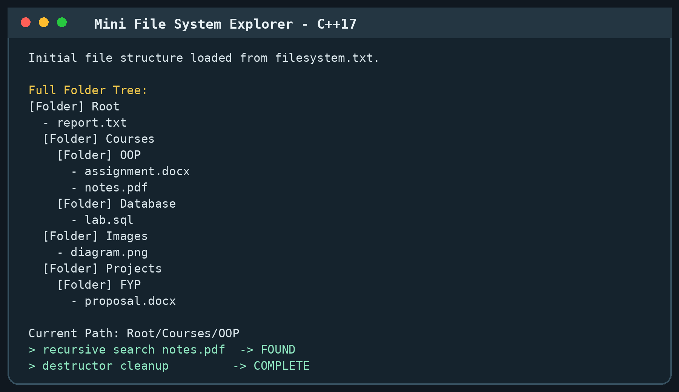
Demonstration output: loaded hierarchy, recursive tree display, path navigation, search, and cleanup.
3  CORE CLASSES | 7  SOURCE/HEADER FILES | 1  TEXT-BASED INITIAL DATASET | C++17  COMPILER STANDARD

KEY ENGINEERING DECISION
Folder objects own their child-folder pointers. Deleting the root starts recursive destruction, ensuring that the dynamically allocated hierarchy is cleaned safely from one ownership point.

03 | GreenPlate  CCA103 Systems Analysis and Design | Group 9 - University campus food-waste reduction and donation platform

System Vision
GreenPlate is a proposed browser-based platform that connects campus cafeterias, verified donation partners, volunteers, administrators, and sustainability officers. The system centralizes surplus-food listings, reservations, pickup coordination, notifications, verification, and impact reporting.
4  INTEGRATED MODULES | 12  CORE USE CASES | 3  SUPPORTED SDGS | 2  ANALYSIS/DESIGN REPORTS

Integrated Modules
1. Surplus Food Management | Register, update, and remove food listings; capture expiry and safety details.
2. Donation Claiming | Browse available food, reserve quantities, and confirm recipient pickup.
3. Logistics and Pickup | Create pickup schedules, assign volunteers/drivers, and track completion.
4. Admin and Reporting | Verify partners, manage alerts, maintain audit records, and generate SDG reports.

Personal Module Ownership
MODULE 3 - LOGISTICS AND PICKUP
Assigned responsibility in the group report: model the workflows that connect a confirmed donation to a scheduled pickup, a volunteer or driver, delivery proof, and completion status.

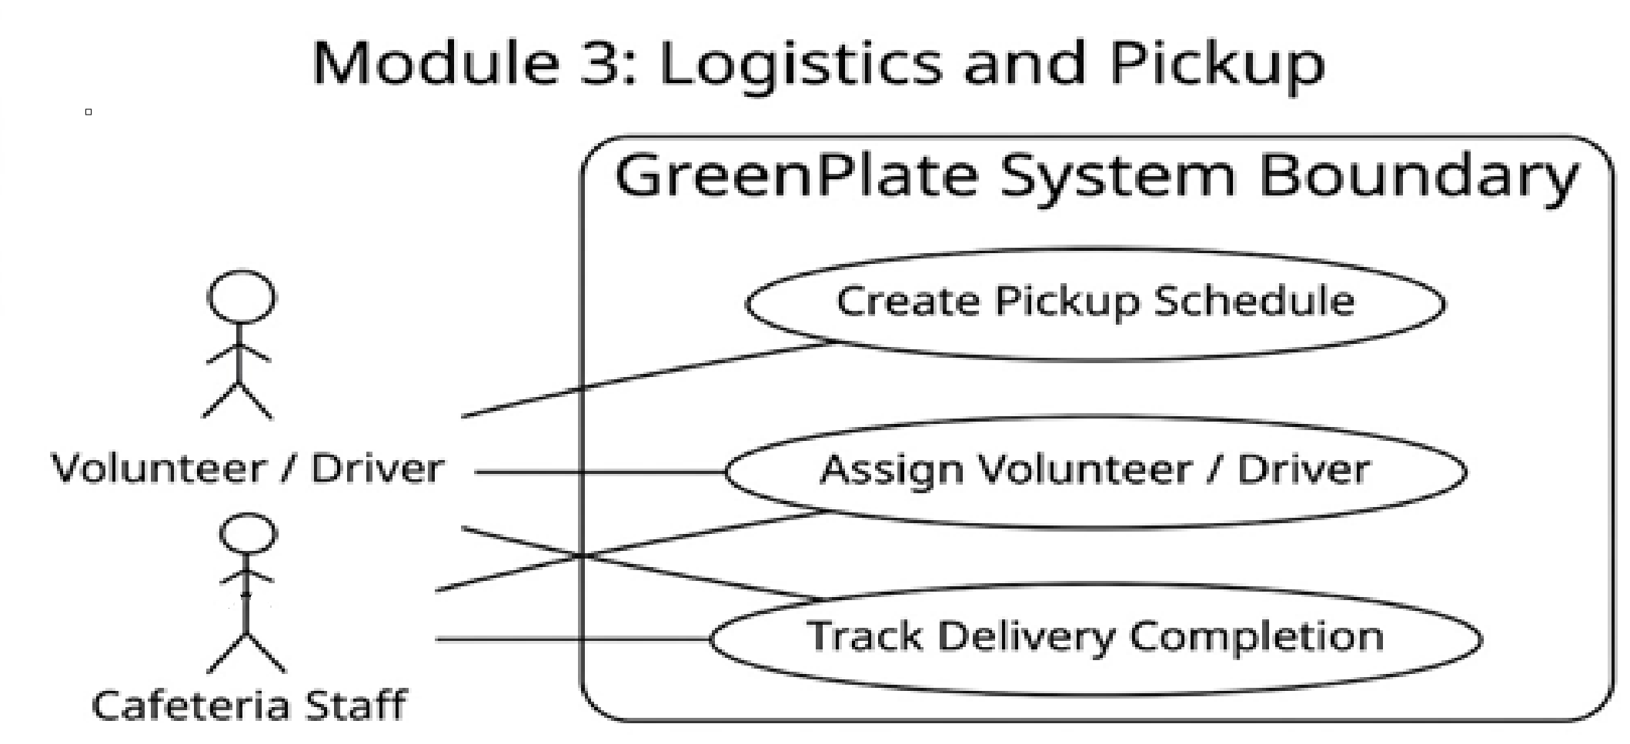
Module 3 use-case diagram: create schedule, assign volunteer/driver, and track delivery completion.
System-Level Deliverables
• Functional and non-functional requirements, stakeholder analysis, feasibility study, risk register, WBS, and Gantt planning.
• Use-case, activity, domain class, system sequence, design class, package, and state-chart models.
• Browser/mobile interface designs, integrity controls, security controls, implementation order, and testing strategy.
SDG ALIGNMENT  • SDG 12: reduce avoidable food waste  • SDG 2: support students and verified recipients  • SDG 13: reduce disposal-related environmental impact | DESIGN FOUNDATION  • Browser and mobile-browser access  • Controller, domain service, repository, and database layers  • QR verification, notifications, audit logs, and reports

03 | GreenPlate - Module 3 Case Study  CCA103 Systems Analysis and Design | Logistics and Pickup workflow design

Workflow Logic
The logistics module transforms a reservation into an accountable pickup task. A volunteer or driver can view open tasks, accept an assignment, upload delivery proof, and close the task. The design coordinates the browser view, controller, domain service, repository, and database layers.
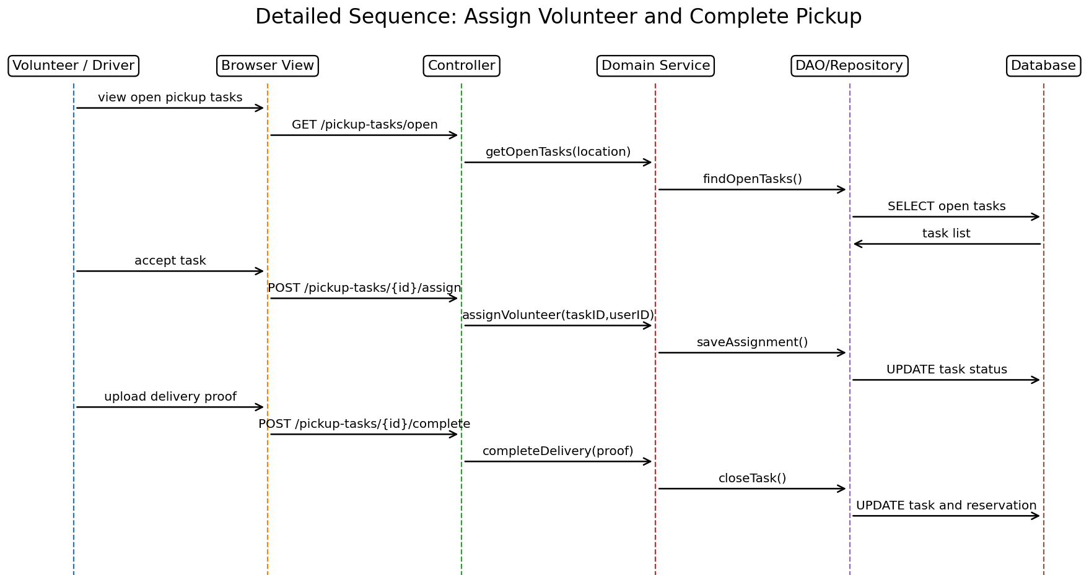
Detailed sequence: view open tasks, accept assignment, upload proof, and complete delivery.
INTEGRITY CONTROLS  • Unique reservation and pickup identifiers  • Status validation before assignment or completion  • Required proof and timestamp fields  • Transaction-safe updates to task and reservation records | SECURITY & ACCOUNTABILITY  • Role-based access for staff, volunteers, partners, and admins  • Secure authentication and protected administrative actions  • Audit logs for listings, claims, pickups, and decisions  • QR verification and controlled file upload for proof

Expected Impact
• Reduce avoidable campus food waste by shortening the time from listing to collection.
• Improve donation traceability through clear ownership, status transitions, and proof of completion.
• Support SDG 12, SDG 2, and SDG 13 reporting with measurable operational records.
PROJECT STATUS
This is a complete analysis and design specification rather than a deployed production system. The reports define the foundation for later implementation, integration, and acceptance testing.

04 | Smart Shuttle & Eco Room  CKC113 Fundamental of Artificial Intelligence | Group project - intelligent agents for campus issues

Project Overview
A conceptual AI project proposing two intelligent agents for USM: a demand-responsive Smart Shuttle agent and an Eco Room study-space allocation and room-control agent. The project includes PEAS analysis, algorithm selection, execution traces, ethical safeguards, an academic report, and a presentation.
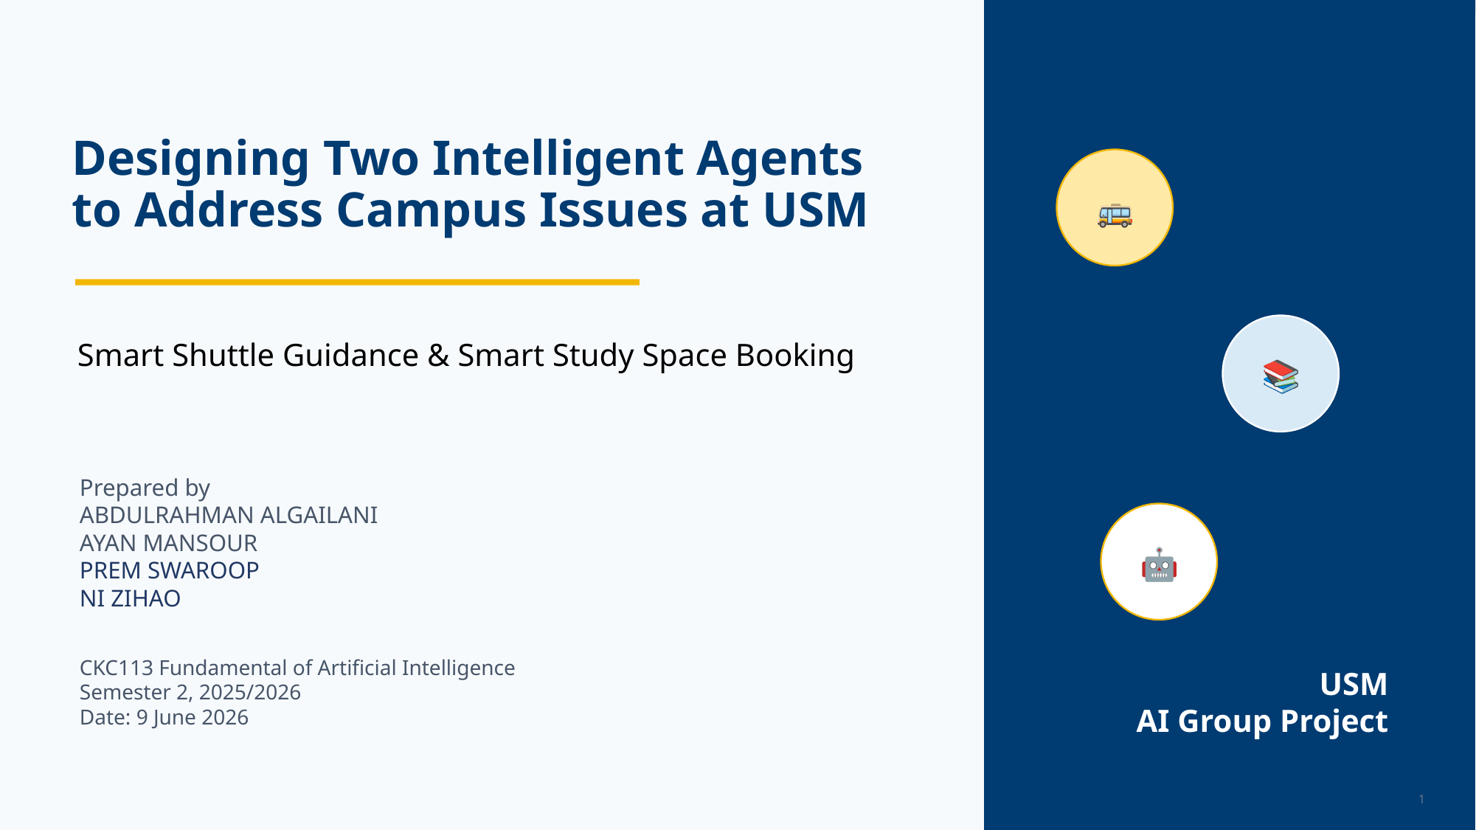
Presentation cover for the CKC113 group project.
SMART SHUTTLE  • Represents campus roads as a weighted graph  • Uses pickup requests, GPS, passenger counts, timetable, and live conditions  • Applies A* Search to route an available bus toward high-demand stops  • Targets lower waiting time, travel time, and unfair route neglect | ECO ROOM  • Models room booking as a Constraint Satisfaction Problem  • Uses backtracking to assign room-time slots without conflicts  • Combines booking data with RFID check-in, PIR occupancy, locks, and power relays  • Releases no-shows and reduces unused-room energy consumption

2  INTELLIGENT AGENTS | 2  SEARCH STRATEGIES | 4  PEAS DIMENSIONS | 6  ETHICAL THEMES

04 | Smart Shuttle & Eco Room - Reasoning Evidence  CKC113 Fundamental of Artificial Intelligence | Algorithms, PEAS analysis, and responsible AI

Algorithm Fit
A* FOR PATHFINDING  • f(n) = g(n) + h(n)  • g(n): known travel cost  • h(n): estimated remaining cost  • Suitable for weighted campus-route graphs  • Can return an optimal route with an admissible heuristic | CSP + BACKTRACKING  • Variables: booking requests  • Domains: room and time-slot options  • Constraints: capacity, schedule, operating hours, and fairness  • Backtracks immediately when an assignment violates rules  • MRV can prioritize requests with the fewest options

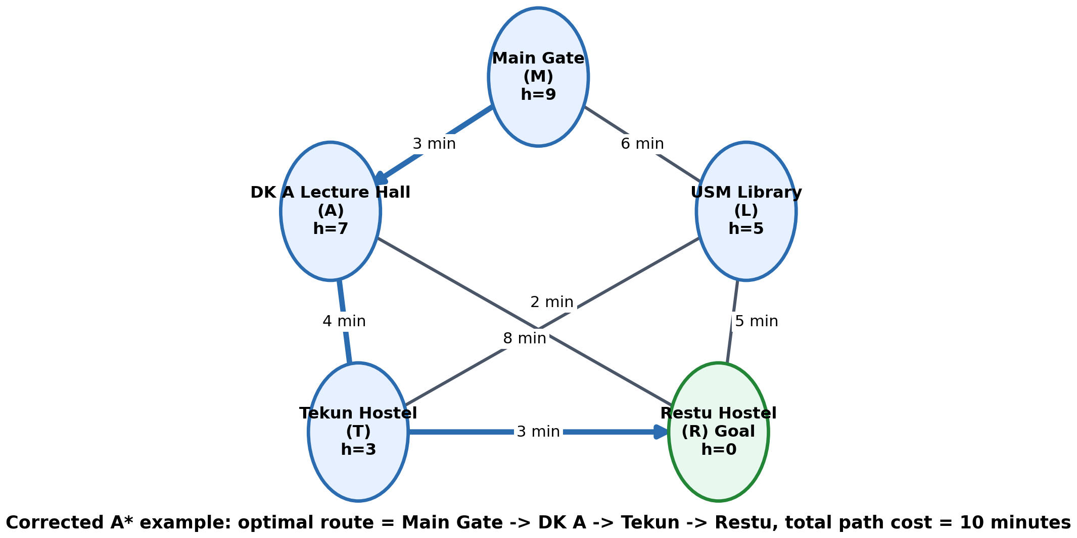  A* campus graph and optimal route trace. | 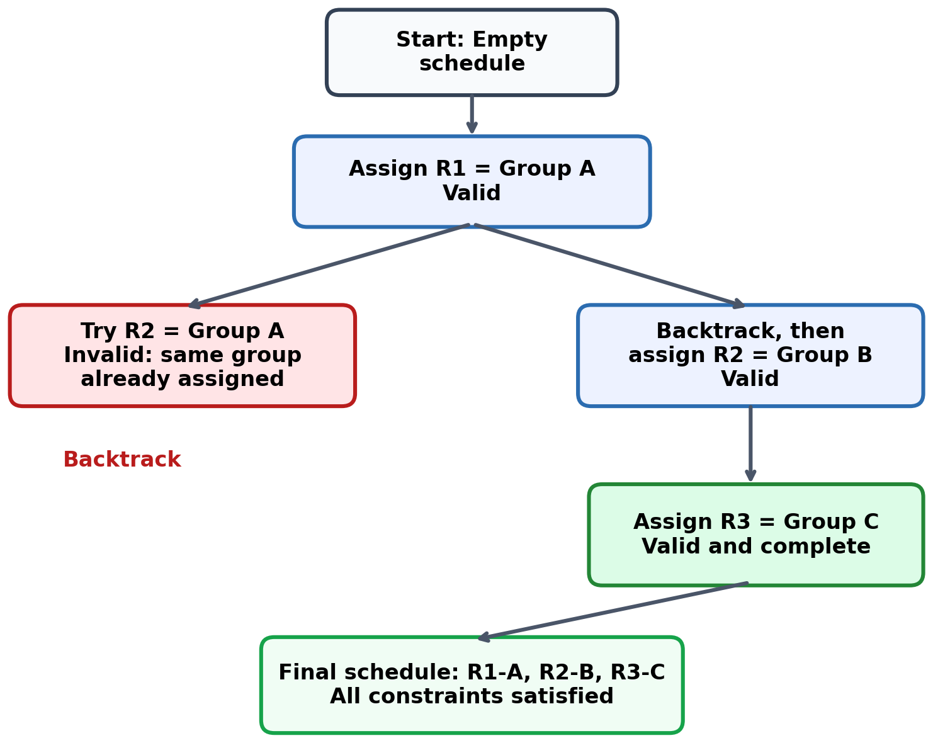  Backtracking branch and final valid schedule.
Responsible AI Safeguards
Privacy | Collect only necessary data; make location sharing optional where possible.
Security | Protect sensitive records through encryption, access control, and secure logs.
Fairness | Prevent repeated priority for the same routes, users, or room-booking groups.
Transparency | Explain why a route, room, cancellation, or priority decision was made.
Human control | Allow staff override for emergencies, accessibility needs, and special cases.
Accountability | Monitor errors, complaints, system performance, and unintended harm.

05 | Competency Evidence  A skills matrix linking each capability to visible work in the portfolio

CAPABILITY | PROJECT EVIDENCE | VISIBLE INDICATORS
Object-oriented programming | Hotel Review System; Mini File System Explorer | Classes, inheritance, composition, encapsulation, destructors, operators
Data structures & memory | Mini File System Explorer | Vectors, pointers, parent-child ownership, recursive cleanup
File processing | Both C++ applications | Text-file loading, parsing, runtime updates, controlled output
Algorithms & reasoning | Hotel ranking; A*; CSP/backtracking | Ranking logic, graph search, heuristics, constraint checking
Requirements analysis | GreenPlate | Functional/non-functional requirements, scope, stakeholders, traceability
UML & architecture | Hotel Review System; GreenPlate | Class, use-case, sequence, package, state, and activity models
Responsible design | AI agents; GreenPlate | Privacy, security, fairness, integrity, auditability, human oversight
Technical communication & management | All four projects; LSP201 English; AKW103 Management | Reports, presentations, teamwork, academic communication, and management fundamentals
Portfolio Reflection
Across these projects, the strongest recurring pattern is structured problem solving. Each task begins by defining the users, data, constraints, and expected outputs. The programming assignments then convert those requirements into class ownership and executable behavior, while the systems-analysis and AI projects expand the same discipline into workflows, architecture, search strategies, safeguards, and evaluation plans. LSP201 English and AKW103 Management complement the technical work through communication and management-focused coursework.
NEXT DEVELOPMENT DIRECTION
A natural next stage is to convert selected designs into deployable applications: add graphical or web interfaces to the C++ concepts, implement a GreenPlate prototype with a database and authentication, and test the campus agents using live or simulated operational data.

06 | Project Archive & Contact  Source evidence reviewed to build this portfolio

Portfolio Evidence Files
FILE | PORTFOLIO EVIDENCE
Group_1_CKC112_Assignment_1.ipynb | Hotel Review System specification, C++ source, UML, compilation, demonstrations, and output files.
Mini File System Explorer Assignment(1).ipynb | Multi-file C++17 source, initial filesystem dataset, compilation, and terminal demonstrations.
GreenPlate Report System Analysis Report 1(3).docx | Problem definition, planning, requirements, UML analysis models, and design strategy.
GreenPlate Report 2(3).docx | Architecture, detailed design, user interfaces, controls, implementation, and testing plan.
AI report(4).docx | Smart Shuttle and Eco Room report with PEAS, algorithms, traces, ethics, and recommendations.
USM AI Intelligent Agents Presentation(3).pptx | Fifteen-slide presentation summarizing the intelligent-agent project.
uml_final.png / Class Description Diagram.svg | Hotel Review System class diagram and relationship evidence.

Academic Integrity Note
The portfolio distinguishes executable applications from conceptual designs and identifies collaborative work as group work. GreenPlate ownership is stated specifically for Module 3: Logistics and Pickup. The intelligent-agent project is presented as a co-authored group deliverable rather than as an individual implementation.
ABDULRAHMAN  ALGAILANI  Computer Science Student | CONTACT  abdulrahmaanaljailani@gmail.com  Universiti Sains Malaysia | School of Computer Sciences
Thank you for reviewing this portfolio.
Selected work demonstrates programming, system design, intelligent-agent reasoning, and technical communication.

